**Project #3**

**Sarav Simranpal Kaur Kular**

**INFO1265**

**January 4, 2018**

**TABLE OF CONTENTS**

**Introduction**

**description**

**research**

**technical issues**

**use cases**

**1. Registering to enter data**

use case / diagram

content plans

prototypes

**2. Enter data**

use case / diagram

content plans

prototypes

**3. messaging**

use case / diagram

content plans

prototypes

**Entities**

**personas**

**persona calculation**

**conclusion**

**Introduction**

Mobile apps are originally offered for general productivity and information retrieval, including accountability, stock market and weather information and Navigation. The app ‘travelex’ is Mobile streamlines business travel and gives travelers the flexibility to manage their itineraries on the go. This app is created by Sarav Simranpal Kaur Kular. Travelex may be accessed by a large range of Smartphone’s over the Internet and mobile networks. Usage of mobile apps has become increasingly prevalent across mobile phone users. Developing apps for mobile devices requires considering the constraints and features of these devices. Further on, Mobile devices run on battery and have less powerful processors than personal computers and also have more features such as location detection and cameras. In Travelex after registering to use the site, users can many travel suppliers automatically send e-receipts into Concur Expense, speeding the process of report creation and submission? Although, Enforce policies with a customizable pre-trip planning process that enables managers to approve, reject and request changes. Moreover, Content draws from multiple global distribution systems, negotiated and published prices, direct connects and web-only fares.

**Description:**

Travelex is a cloud-based service that updates and upgrades automatically. On the web, on a smartphone or on a tablet, we provide a complete suite of tools for you and your employees. Get the most out of business travel and get back all the time used to make expense reports. And also you can claim your expenses by company online and receive notifications. Our customers range from small businesses to the FP 500, so we know a lot about how different companies work. We can scale up or down based on your company's size, spending goals, policy complexity and travel program needs. No matter how big or small your company is, Concur has a travel, expense and invoice solution for you. And with the growing partner community building around our platform, you’ll have access to a growing feature and application market.

**Research**

Dear Customer,

We are about to launch a new application that allows you to manage your business schedule, book cubicles for meetings, and keep lists of contacts. The purpose of this survey is to gain your perspectives about your needs in the application.

Below is a link to the online survey. The survey is user-friendly and consisted of 12 questions. We are grateful for your willingness to participate and value your opinion. Our hope is this process will help us develop more refined user experience.

Thank you.

Q1. What is your age?

|  |  |
| --- | --- |
| * Under 18 years old * 20-24 years old * 30-34 years old * 40-44 years old * 50 years old or older | • 18-20 years old  • 25-29 years old  • 35-39 years old  • 45-49 years old |

Q2. What is your gender?

|  |  |
| --- | --- |
| * Male | • Female |

Q3. What is your marital status?

|  |  |
| --- | --- |
| * Single, never married * Common-law partner * Separated | • Married  • Divorced  • Widowed |

Q4. What is your position in the company?

|  |  |
| --- | --- |
| * Chairman or Vice-chairman * Executive * Assistant Manager | • President or Vice-president  • Manager  • Staff |

Q5. What is your first impression of the service of the application?

|  |  |  |  |  |
| --- | --- | --- | --- | --- |
| 1 | 2 | 3 | 4 | 5 |
| Very Positive | Positive | Neutral | Negative | Very Negative |

Q6. Do you think of it as something you need or don’t need?

|  |  |  |  |  |
| --- | --- | --- | --- | --- |
| 1 | 2 | 3 | 4 | 5 |
| Definitely need | Probably need | Neutral | Probably not | Definitely not |

Q7. If the application were available today, how likely would you be to use the application?

|  |  |  |  |  |
| --- | --- | --- | --- | --- |
| 1 | 2 | 3 | 4 | 5 |
| Very likely | Likely | Neutral | Not so likely | Not at all likely |

**Technical Issues:**

* Android and iOS are two extremely different platforms. It's not enough to simply clone your iOS app for Android.
* You have to type in your address, email address, and confirm that you selected the right product— all on a tiny screen.
* The biggest usability issue that the most businesses overlook when it comes to mobile apps is the lack of actual user testing outside of their corporation. You need to get feedback from outside users and determine the intent, needs and usability obstacles.
* Not supporting both landscape and portrait orientation
* Keeping updated with the Dynamic technology world and the expectation of the users.
* Various device screen sizes
* Battery consumption (Limited power: Till now, battery is still the limiting factor for mobile devices. If your app consumes too much power too quickly, your users may abandon and uninstall your app.)
* Memory consumption and performance
* Data security
* Scalability
* Framework and platform knowledge
* Mobile content management
* Diverse target systems: Many Android devices are not updated. You have to consider your target users when picking the API version for your app

**Use Cases**:

1. Registering to enter data

Use case

|  |  |  |
| --- | --- | --- |
| UC Name | Registering to an app | |
| Brief Description | User register himself on the app. | |
| Actors | User | |
| Normal Flow of Events | User | System |
|  |  | 1. Displays a dialogue box to sign in and below it there is option to register if you are new on site. |
|  | 2. ask for your information | 3. Selects confirm. |
|  | 4. A verification dialogue box will appear. | 5. Now you are registered and your account is activated. |
|  | 6. confirms | 7. sends user’s information to the system |

Diagram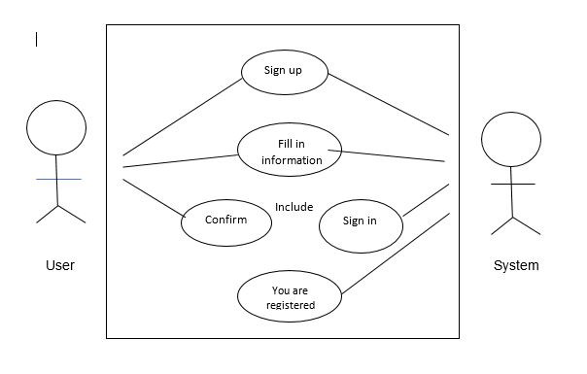

Content Plan and Prototypes

1. Page: sign in
   * 1. Header
   * Representative image of title
   * Title: Travelex
     1. Main

* username or email (for already registered users)
* forget password
* sign up
* 9new users)

1. Page: forget password
2. Header
   * Representative image of title
   * Title: Travelex
3. Main

* Enter email or username
* Button:

Register

1. Page: Signing up
   * 1. Header
        + Back button
   * Title: Travelex
     1. Main
        + User information for signing up event
          - username
          - create password
          - terms and policies dialogue box
        + Button
          - Register

Prototypes

|  |  |
| --- | --- |
| A. signing in to app | B. signing up to register with new user |

* 1. Forget password

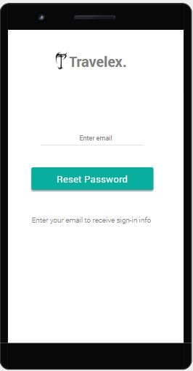

2. Enter data

Use case

|  |  |  |
| --- | --- | --- |
| UC Name | Enter data | |
| Brief Description | Enter your accounts in respective fields | |
| Actors | User | |
| Normal Flow of Events | User | System |
|  |  | 1display expenses folder to add your daily accounts |
|  | 2. upload receipts under particular name | 3. displays the list |
|  | 4. add dates and amount spend | 5. saves all information in particular folder |
|  |  |  |
|  | 6. confirms | 7. saves it on the system |

Diagram

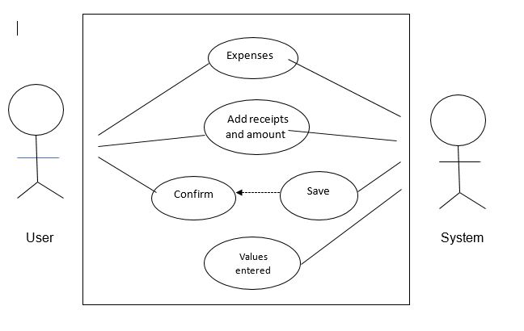

Content Plan

* 1. Page: displaying different options
     1. Header
  + Representative image of title
  + Title: Travelex
  + Menu
  + Messages
    1. Main (lists of venues)
       - Dropdown menu (“Sort by”)
         * Expenses
         * Expense reports
         * Approvals
    2. Tabs (across bottom, icons)
       - Receipt
       - Add expenses
  1. Page: Add Expenses
     1. Header
        + Back button
        + Title: Expenses
        + Representative image
     2. Main
        + Tabs (across top of main)
          - Receipts
          - Date
          - Amount
        + Button
          - Add
  2. Page: Expense reports
     1. Header
        + Back button
        + Title: Reports
        + Add (icon)
     2. Main
        + Tabs (across top of main)
          - Claims
          - Amount
          - Date
          - Facilities
        + Button
          - Add
  3. Page: Report approval
     1. Header
        + Back button
        + Title: report approval
     2. Main
  + Data entries
  + Date
  + Amount

Prototypes

|  |  |
| --- | --- |
| * 1. display different options | * 1. adding expenses |
| C. expense reports | D. approvals |

3. Messaging

Use case

|  |  |  |
| --- | --- | --- |
| UC Name | messaging | |
| Brief Description | Messaging as notifications | |
| Actors | User | |
| Normal Flow of Events | User | System |
|  |  | 1. shows users notifications and messages |
|  | 2. send and receive messages | 3. ask user to save or delte message |
|  | 4. mark the messages as starred messages | 5. reply for messages |

Content Plan

* 1. Page: messaging
     1. Header
        + Back button
        + Title: messages
        + Sort by (Dropdown menu)
          - Date
     2. Main
        + List of messages
        + Buttons
          - Cancel
          - Save

3. Tabs (across bottom, icons)

* + - * Home
      * My account

Prototypes:

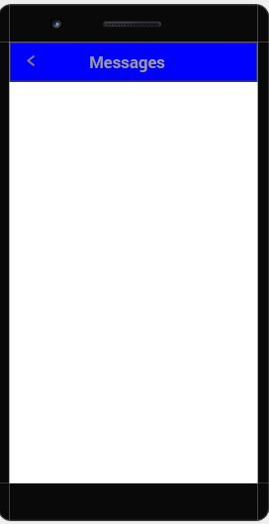

**Personas**

|  |  |
| --- | --- |
| Name | Jagsimran pal singh |
| Age | 25 |
| Occupation (if applicable) | Traveller agency |
| Location | Kitchener, ON |
| Interest Level in the App’s Field | Connoisseur |
| Demographics | Professional |
| Computer Skills | Expert computer programmer |
| Motivations and goals with respect to the field (of the app) | * To develop company demand draft * To improve himself in respective field * To build a strong relationship with co-workers |
| Frustrations with respect to the field | * Competing with more professional developers and publishers * Finding a good work place or meeting space * Balancing between work and self-development |

|  |  |
| --- | --- |
| Name | Abhishek Nain |
| Age | 30 |
| Occupation (if applicable) | Manager of Sales Department |
| Location | Kitchener, ON |
| Interest Level in the App’s Field | Professional |
| Demographics | Professional |
| Computer Skills | Casual (email and social media) |
| Motivations and goals with respect to the field (of the app) | * To find balance between work and life * To move to better neighborhood for her daughter * To manage her time more effectively to spend more time with her daughter |
| Frustrations with respect to the field | * Finding a perfect daycare that allows flexible pickup time * Spending too many time on road * Building a secure relationship with clients |
| Projected interest in the app | * Booking a cubicle for meetings at her convenience * Booking a daycare for her daughter * Manage her account schedules |

Persona Calculation

|  |  |  |  |
| --- | --- | --- | --- |
|  | Jagsimran pal singh | Abhishek nain | Weighted Sum |
| Weight (%) | 40 | 30 |  |
| Weight (0 to 1) | 0.4 | 0.3 |  |
| Book a Cubicle | 5 | 4 | 4.1 |
| Book a Daycare | 1 | 4 | 1.9 |
| Sign up a public meeting | 5 | 2 | 3.8 |
| Manage Schedule | 3 | 4 | 3.9 |
| Manage Contact List | 4 | 4 | 4.3 |
| Scan business cards | 3 | 3 | 3.6 |
| Send instant messages | 4 | 3 | 3.1 |

**Entities**

|  |  |  |
| --- | --- | --- |
| MEMBER |  | EVENT |
| User ID  User Nickname  User contact number |  | Expenses  Expense reports  Approvals |

|  |  |  |
| --- | --- | --- |
| Add expenses |  | Data entries |
| Name  Date  Amount  Receipts |  | Name  Time and date  Liabilities  User IDs and nicknames  Debits  Facilitator |

|  |  |  |
| --- | --- | --- |
| MEMBER |  | Company claims |
| Reports  Amount approval by  company |  | User ID  Claim reports  Approved by company  Notifications and messages |

**Conclusion**

The key of Travelex is users’ satisfaction. The majority of the system relies on Get complete visibility into spending as its happening. Process expenses and invoices 30% faster. Ensure spending stays within your policies. Keep your business on track and on budget. As your company grows, expenses and hassles grow too. Keeping track of cash flow can become increasingly difficult. Thousands of users in Canada will depend on Travelex every day Therefore, the most essential job for the app should be offering the most pleasant user experience with simple steps and an intuitive interface.